

Name of Series:
Presentation Title: Oncology Updates with ASCO Highlights - St. Louis
Date: June 21, 2025 Time: 7:30 AM - 3:45 PM
Location: DoubleTree by Hilton Hotel - St. Louis

Speaker(s) including affiliation:
Michelle Padgett, ATC
WashU Medicine

Objectives :
1 Summarize recent and emerging data from key studies in
clinical and translational cancer research for the following
areas; breast cancer; genitourinary cancer; gastrointestinal
tract cancer; lung cancer, central nervous system tumors,
sarcomas, melanomas and lymphomas.

2 Implement strategies designed to improve the quality of
cancer care, address barriers to optimal care, enhance the
patient experience and improve communication within the
medical team
3 Report and share information about the newest clinical trials
available for patients with different malignancies, or specific
genetic mutations indicative of possible drivers for tumors.
Apply results of recent trials and future trials
4 Improve strategies and communication skills to work with a
multi-disciplinary team, including nurse practioners, nurses,
and clinical pharmacists, to better communicate with patients
in order to assess toxicity from cancer-directed therapies
and improve patient quality of life.
5 Manage toxicities of newer cancer therapies

Topics:

Disclosure:

All disclosures are valid for one year from the Last Confirmed date. If older than one year from the date of the talk, the disclosure must be updated.

All of the relevant financial relationships listed for these individuals have been mitigated.

The planners, faculty/presenters, reviewers, and others in control of content (either individually or as a group) for this educational activity have disclosed the following financial relationships:

Name of individual | Individual's role in activity | Nature of Relationship(s) / Name of Ineligible Company(s)
Michelle Padgett, ATC | Activity Administrator, Activity/Series Coordinator, Faculty | Nothing to disclose - 03/10/2025

All members of the CME department have nothing to disclose.

Accreditation:

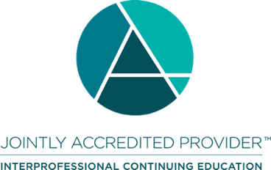
In support of improving patient care, Washington University School of Medicine in St. Louis is jointly accredited by the Accreditation Council for Continuing Medical Education (ACCME), the Accreditation Council for Pharmacy Education (ACPE), and the American Nurses Credentialing Center (ANCC), to provide continuing education for the healthcare team.

Credit Available for this Activity:

This activity is approved for a maximum of 5.75 knowledge-based contact hour(s) in states that recognize ACPE. Participants should only claim credit commensurate with the extent of their participation in the activity. To be awarded credit, attendees must sign in, provide their NABP ePID number and date of birth.

Washington University School of Medicine in St. Louis has designated this educational activity for a maximum of 5.75 AMA PRA Category 1 Credit(s)™. Physicians should only claim credit commensurate with the extent of their participation in the activity.

Washington University School of Medicine in St. Louis designates this live activity for a maximum of 5.75 ANCC Contact Hour(s).

This activity was planned by and for the healthcare team, and learners will receive 5.75 IPCE credit(s) for learning and change.

